Table of Contents

Introduction to GitHub's products 1

Learning objectives 1

Introduction 1

GitHub products attach features to licensing plans. Understanding the various products, features, and licensing is an important consideration when using GitHub in organizations and enterprises. 1

Learning objectives 1

Prerequisites 2

What are GitHub's products? 2

A focus on GitHub products 2

GitHub Free 2

GitHub Pro 3

GitHub Team 4

GitHub Enterprise 4

GitHub Enterprise Cloud 5

Recap 5

How does licensing work for GitHub features? 5

Licensing for metered products 6

Licensing GitHub Packages 6

What are spending limits? 7

Codespaces billing 7

How can I view my usage of products and services? 8

Context switching for organization or enterprise owners 8

Manage licenses across organizations 9

Manage licenses across enterprises and instances 9

Monitoring consumption of metered products 9

Set spending limits 10

Monitor Git LFS data 10

Further reading 11

Summary 11

**Introduction to GitHub's products**

Intermediate

Administrator

DevOps Engineer

Technology Manager

GitHub

Overview of GitHub's products, associated features, and licensing of per-use and metered features.

**Learning objectives**

After completing this module, you'll be able to:

* Explain the difference between each GitHub product, and which features are available with each product.
* Make key distinctions between plans, account types, teams, repository permissions, organization permission levels, and so on.
* Describe licensing terms for GitHub Actions, GitHub Packages, and Codespaces.

**Introduction**

GitHub products attach features to licensing plans. Understanding the various products, features, and licensing is an important consideration when using GitHub in organizations and enterprises.

Suppose you work at a company that needs to rethink their existing source code management strategy. They know they want to use GitHub, but they aren't sure which features they need, how much it would cost, and how to get started. Your company's VP of software development wants to better understand the costs associated with GitHub and has asked you to become the subject matter expert and help to make this change in the organization.

In this module, you'll discover GitHub's products and associated features. You'll learn how each product is priced, and discover how other features are licensed.

By the end of this module, you'll be able to discuss GitHub's products, features, and licensing.

**Learning objectives**

After completing this module, you'll be able to:

* Explain the difference between each GitHub product, and which features are available with each product.
* Make key distinctions between plans, account types, teams, repository permissions, organization permission levels, and so on.
* Describe licensing terms for GitHub Actions, GitHub Packages, and Codespaces.

**Prerequisites**

* Familiarity with GitHub, repositories, and the basics of managing individual accounts is required
* A high-level familiarity with GitHub's product plans and features would be helpful, but isn't required

# 

# What are GitHub's products?

In this unit, you'll learn about available GitHub products, corresponding product features, and pricing.

## A focus on GitHub products

GitHub has several free and paid products to improve your software management process and team collaboration:

* GitHub Free
* GitHub Pro
* GitHub Team
* GitHub Enterprise

As you learn about these products, remember that there's a difference between products and accounts. Here's a list of the three GitHub account types:

* Personal user accounts
* Organization accounts
* Enterprise accounts

Some account types are available only within specific products. In the following sections, you'll learn more about these products, their different features, and which account types they're compatible with. As you move through the content, make it your goal to understand these separate but related concepts so that you can decide which GitHub product is right for you.

### GitHub Free

This is often the product version that comes to mind when thinking of GitHub. GitHub Free provides the basics for individuals and organizations. Anyone can sign up for the free version of GitHub. Signing up for GitHub Free will give a new user a Personal user account. A personal user account includes unlimited public and private repositories and unlimited collaborators. Private repositories under GitHub Free have limited functionality, GitHub Actions minutes, and GitHub Packages storage.

Here's a breakdown of the features included with GitHub Free:

* Unlimited public/private repositories
* 2,000 Actions automation minutes/month (Free for public repositories)
* 500 MB of Packages storage (Free for public repositories)
* 120 core-hours Codespaces compute/month
* 15 GB of Codespaces storage/month
* New issues & projects (in limited beta)
* GitHub Community Support
* Dependabot alerts
* Two-factor authentication enforcement

For a more comprehensive description of features and available add-ons, refer to [GitHub's pricing page](https://github.com/pricing?azure-portal=true).

#### GitHub Free for organizations

GitHub Free also includes a free version specifically for organizations. The organization version has all the features of the personal account and two extra features:

* Team discussions
* Team access controls for managing groups

### GitHub Pro

GitHub Pro is the same as GitHub Free but with some upgraded features. This product is available for individual developers who want advanced tools and insight within their repositories but don't belong to a team - these are individual developers using their personal accounts. GitHub Pro accounts include all of the features of a GitHub Free account, plus the following advanced features:

* GitHub Support via Email
* Required pull request reviewers
* Multiple pull request reviewers
* Auto-linked references
* GitHub Pages
* Wikis
* Protected branches
* Code owners
* Repository insights graphs

In addition, GitHub Pro increases the limits of GitHub Actions and GitHub Packages for private repositories.

| **Feature** | **Limit** |
| --- | --- |
| GitHub Actions minutes | 3000 |
| GitHub Packages storage | 2 GB |
| GitHub Codespaces core-hours | 180 |
| GitHub Codespaces storage | 20 GB |

Note

GitHub Pro doesn't show up on the pricing page, but is available as an upgrade to personal user accounts once the user is logged in. If the account already belongs to an organization, GitHub Pro will not be available, instead GitHub Team will show as an available upgrade.

### GitHub Team

GitHub Team is the version of GitHub Pro for organizations instead of personal accounts. GitHub Team includes all the same features as GitHub Pro and a few extra features that help with collaboration within a team:

* Draft pull requests
* Team pull-request reviewers
* Scheduled reminders

### GitHub Enterprise

GitHub Enterprise can be hosted on-premises (GitHub Enterprise Server) or in the cloud (GitHub Enterprise Cloud) using GitHub's existing infrastructure. GitHub Enterprise accounts enjoy a greater level of support and extra security, compliance, and deployment controls.

You can create one or more enterprise accounts by signing up for the paid GitHub Enterprise product. When you create an enterprise account, you're assigned the role of enterprise owner. As an enterprise owner, you can add and remove organizations to and from the enterprise account. You can manage other administrators, enforce security policies across organizations, and so on.

With GitHub Enterprise, you get GitHub Enterprise Support and a greater integration with existing on-premises or cloud services. For example, you can synchronize your authentication with SAML to enable single sign-on by using your existing configurations stored in Active Directory Federation Services or Azure Active Directory. Alternatively, you can provision access to other services by using SAML or SCIM as the identity provider. You can also use GitHub Connect to share certain features and data between your GitHub Enterprise Server instance, your GitHub Enterprise Cloud organization, or your enterprise account on GitHub.com.

In addition to the features available with GitHub Team, GitHub Enterprise includes:

* GitHub Enterprise Support
* More security, compliance, and deployment controls
* Authentication with SAML single sign-on
* Access provisioning with SAML or SCIM
* GitHub Connect
* The option to purchase GitHub Advanced Security

### 

### 

### GitHub Enterprise Cloud

The hosted cloud version of GitHub Enterprise includes a dramatic increase in GitHub Actions minutes and GitHub Packages storage.

| **Feature** | **Limit** |
| --- | --- |
| GitHub Actions minutes | 50,000 |
| GitHub Packages storage | 50 GB |

In addition to the increased minutes, you also get the following extra features with GitHub Enterprise Cloud:

* Access control for GitHub Pages
* A service level agreement for 99.9% monthly uptime
* Centralized billing options

## Recap

In this unit, you covered the following topics:

* An explanation of the intricate relationship between products and account types.
* A list of available GitHub products.
* A summary of product features that are contingent on your product type. Free accounts provide basic GitHub features. Paid accounts build on the free account features with improved support options, and increased GitHub Actions minutes and GitHub Packages storage along with features for collaboration, control, and reporting.
* A review of the advanced features included with GitHub Enterprise such as increased access to support, more security, compliance, deployment controls and single sign-on.

# 

# How does licensing work for GitHub features?

Completed 100 XP

* 4 minutes

The availability of some of the GitHub features discussed in the previous unit depends on the product type. Other features, however, are "rate-based". A rate-based feature gives you a certain number of execution minutes or storage capacity, and then requires you to pay for additional usage.

In this unit, we'll look at a few different ways that GitHub licenses and prices certain rate-based features.

## Licensing for metered products

GitHub Actions is free for public repositories and self-hosted runners. For private repositories, each GitHub account receives a certain number of free minutes, depending on the product used with the account.

By default, your account will have a spending limit of $0, which prevents additional usage of minutes after you reach your limit. If you increase your spending limit above the default of $0, you'll be billed for any minutes beyond the limits, also called overages. GitHub charges usage to the account that owns the repository where the workflow is run.

Jobs that run on GitHub-hosted Windows and macOS runners consume minutes at 2 and 10 times the rate that jobs on Linux runners consume. For example, using 1,000 Windows minutes would consume 2,000 of the minutes included in your account. Using 1,000 macOS minutes, would consume 10,000 minutes included in your account.

The following table compares the minute multiplier for the different operating systems.

| **Operating system** | **Minute multiplier** |
| --- | --- |
| Linux | 1 |
| macOS | 10 |
| Windows | 2 |

Finally, the free minutes reset each month. You can't "roll over" unused minutes from previous months.

If your account's usage surpasses these limits and you've set a spending limit higher than $0, you'll pay per-minute usage based on the operating system used by the GitHub-hosted runner. GitHub rounds the minutes each job uses up to the nearest minute.

Note: For current prices, refer to [GitHub's pricing page](https://github.com/pricing?azure-portal=true).

### Licensing GitHub Packages

Storage for GitHub Packages works in a similar way, except that GitHub Packages storage capacity doesn't reset every month.

The storage used by a repository is the total storage used by GitHub Actions artifacts and GitHub Packages. Your storage cost is the total usage for all repositories owned by your account.

GitHub calculates your storage usage for each month based on hourly usage during that month. For example, if you use 3 GB of storage for 10 days of March and 12 GB for 21 days of March, your storage usage would be:

3 GB x 10 days x (24 hours per day) = 720 GB-Hours  
12 GB x 21 days x (24 hours per day) = 6,048 GB-Hours  
720 GB-Hours + 6,048 GB-Hours = 6,768 GB-Hours  
6,768 GB-Hours / (744 hours per month) = 9.0967 GB-Months

At the end of the month, GitHub rounds your storage to the nearest megabyte. Therefore, your storage usage for March would be 9.097 GB.

If your account's usage surpasses these limits and you've set a spending limit higher than $0, you incur an additional fee per gigabyte of storage used per month.

At the end of the month, GitHub calculates the cost of minutes and storage used over the amount included in your account.

Note

For a specific scenario that demonstrates how your bill is calculated with actual dollar amounts, see [calculating minute and storage spending](https://docs.github.com/billing/managing-billing-for-github-actions/about-billing-for-github-actions#calculating-minute-and-storage-spending) in GitHub Docs.

### What are spending limits?

By default, your account will have a spending limit of $0 for GitHub Actions usage. To allow you to use minutes and storage for private repositories beyond the amounts included with your account, you can increase the spending limit or allow unlimited spending.

If you pay for your enterprise account by invoice, your account will have an unlimited default spending limit and you'll be billed for overages. You can set a specific spending limit.

If your account has outstanding unpaid charges:

* The storage or minutes included in your account for GitHub Actions and GitHub Packages won't reset until the payment has been successfully processed.
* For accounts with storage or minutes remaining for the current billing period, GitHub Actions and GitHub Packages will continue to be available until any included usage has been reached.
* For accounts that have reached the included usage for the current billing period for GitHub Actions or GitHub Packages, both GitHub Actions and GitHub Packages will be disabled to prevent any further overages. If you pay your account by invoice, you must contact the account management team to process payment and reset your usage.

## Codespaces billing

GitHub Codespaces usage is billed monthly for all organization and enterprise accounts on GitHub Team and GitHub Enterprise, which don't include any free minutes or storage.

Personal accounts include free use of GitHub Codespaces up to a fixed amount of usage every month.

Compute costs are incurred when a codespace is active. When you're using a codespace, the codespace is active. After 30 minutes of inactivity, a codespace becomes suspended automatically.

The unit of measure for compute usage is one hour, at a rate that depends on your codespace's instance type. Compute pricing may vary for additional instance types and operating systems supported in the future.

Storage is billed for all of your existing codespaces, regardless of whether they're active or inactive, unless your storage quota is used up or you've reached your spending limit. The storage billing for a codespace ends when it's deleted.

## How can I view my usage of products and services?

The GitHub user interface makes it easy for you to find statistics of license usage for a specific organization, or across organizations, enterprise accounts, or instances. Also, you can view details about your license usage for machine accounts and peripheral services.

Licenses for paid products are available to an organization on a per user basis. Each of these licenses is referred to as a seat. It's possible to set up a machine user: a GitHub account that's attached to an SSH key and used exclusively for automation. A machine user also consumes a license.

### Context switching for organization or enterprise owners

Organization or enterprise owners who are responsible for multiple accounts need easy access to those accounts. The GitHub user interface enables context switch, which is the flexibility to sign in to more than one account and move between the accounts.

As an owner, you can select your profile photo and choose the option to switch to a different account.

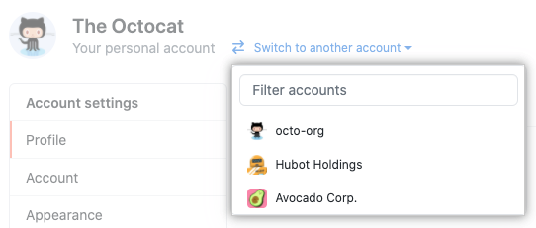

Context switching demonstrates GitHub's capability to enable usage management across accounts.

### Manage licenses across organizations

An organization owner who wants to manage and monitor the number of seats licensed to their organization can select their profile photo and then navigate to **Billing and plans**.

If the owner manages multiple organizations, they'll need to select the organization they want to view.

Screenshot of the settings option for an organization.

They can then view their current plan and add or remove seats.

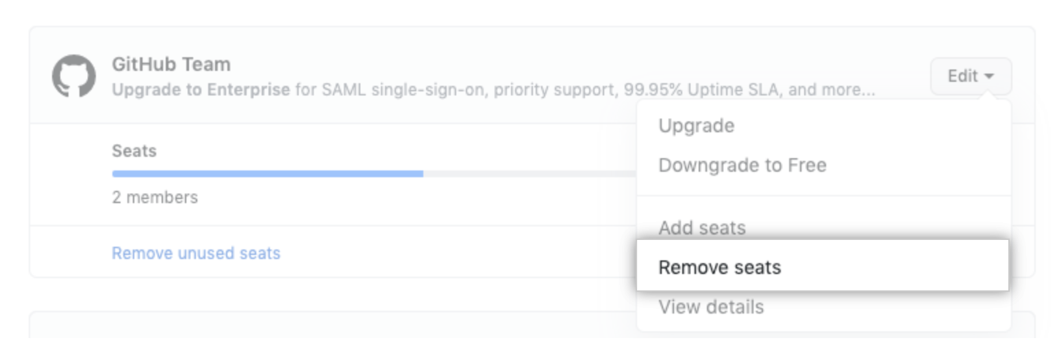

### Manage licenses across enterprises and instances

Enterprise owners that manage multiple enterprises or enterprise instances can also easily view and manage licensing for one or more enterprises, by selecting **Your Enterprises** from the **Settings** dropdown menu in the owner's profile.

GitHub Enterprise Server licenses can be viewed and managed at the server instance level.

### Monitoring consumption of metered products

As you've learned, metered products are billed by the number of minutes or gigabytes consumed beyond the allotted, basic amount. GitHub Actions and GitHub Packages are examples of metered products. The GitHub user interface also enables you to monitor statistics for metered products.

**Billing & plans** provides an overview of your current plans, up-to-date minute usage for GitHub Actions, and storage usage for GitHub Packages.

In addition to viewing data in the GitHub user interface, you can also have CSV reports sent to your email address.

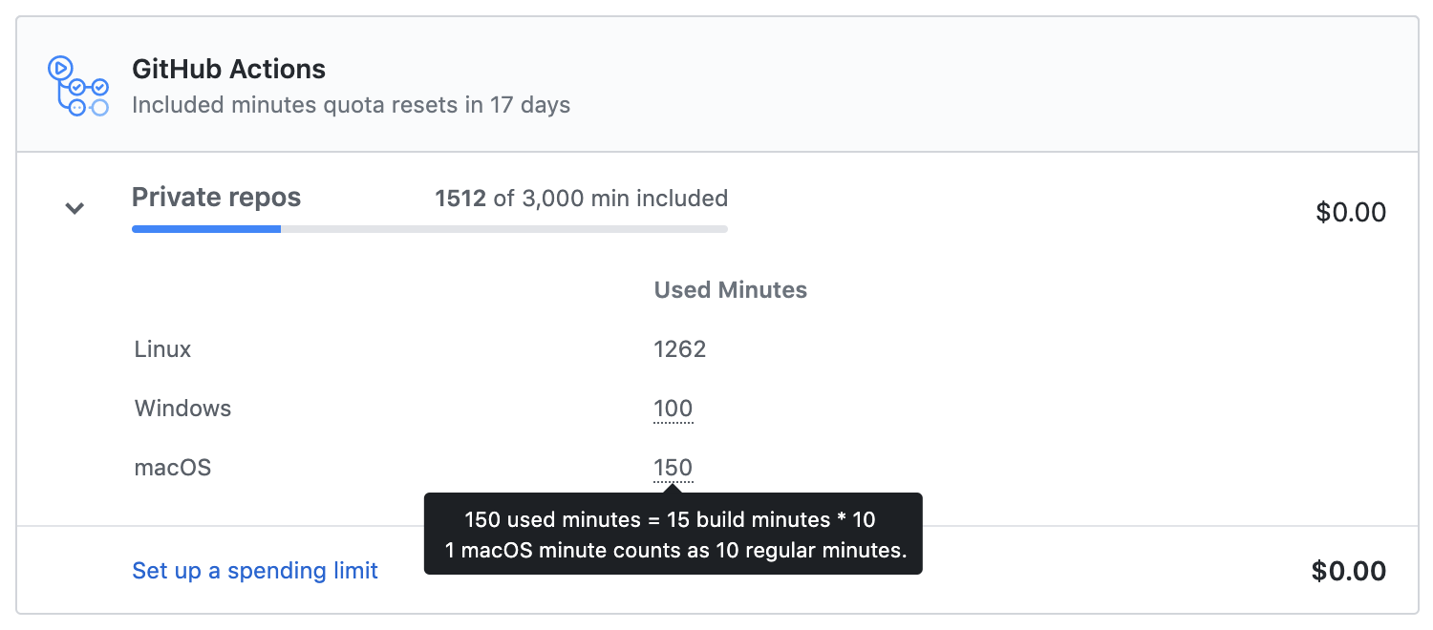

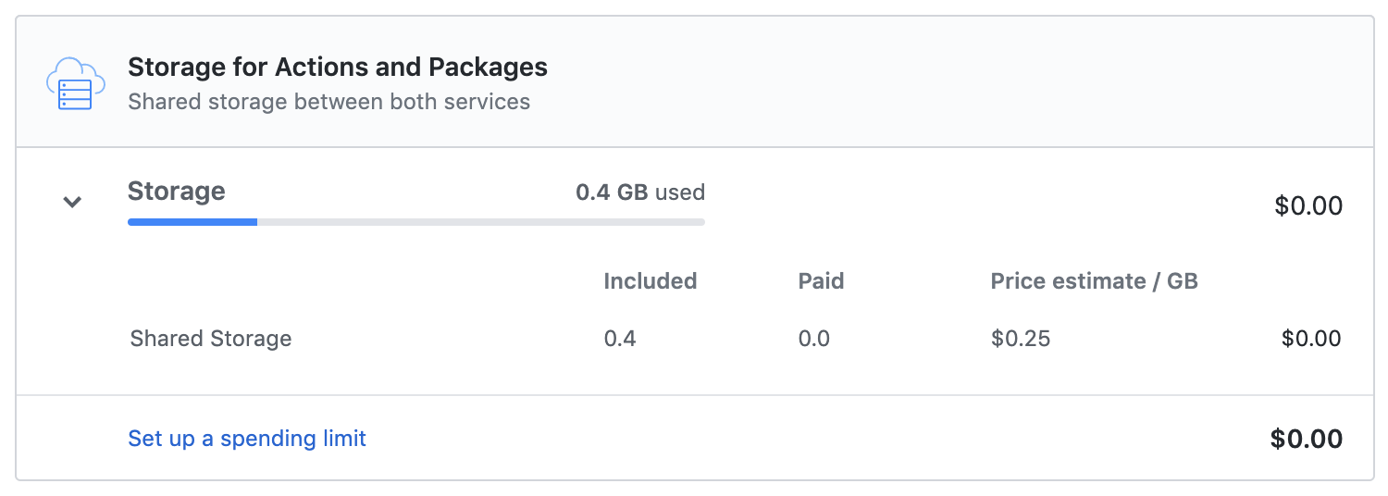

### Set spending limits

You can set limits that control your spending for actions and packages usage. Adjust the limit at any time and according to the growth of your operations.

The safety and control offered by this feature is also noteworthy. Enabled spending limits safeguard you in the event that a configuration error causes your organization to be billed. The billing is capped and the damage is kept to a minimum. This could be thought of as maximum risk.

When misconfiguration isn't the case, a spending limit simply assists you in budgeting your IT expenses.

### Monitor Git LFS data

The GitHub user interface enables management of Git LFS (Large File Storage) Data providing feedback on the amount of storage and bandwidth used. Every account using Git Large File Storage receives 1 GB of free storage and 1 GB a month of free bandwidth. If that's not enough, you can purchase extra. You pay when assets are pushed to or downloaded from your account.

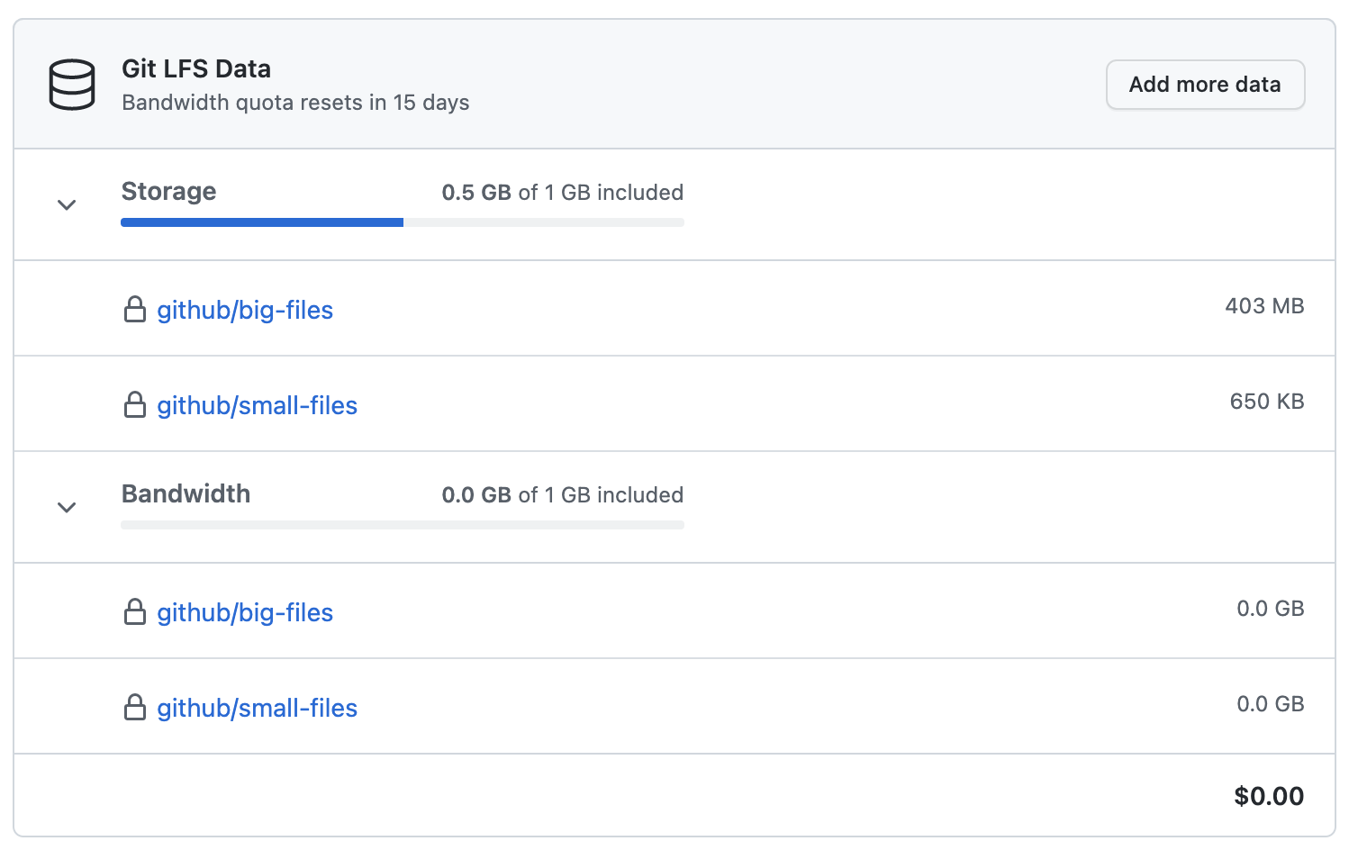

## Further reading

[Switching between settings for your different accounts](https://docs.github.com/en/billing/managing-your-github-billing-settings/about-billing-on-github#switching-between-settings-for-your-different-accounts)

[Managing your license for GitHub Enterprise Server](https://docs.github.com/enterprise-server@3.8/billing/managing-your-license-for-github-enterprise?azure-portal=true)

[Managing your license for GitHub Enterprise Cloud](https://docs.github.com/enterprise-cloud@latest/billing/managing-your-license-for-github-enterprise?azure-portal=true)

[Viewing your GitHub Actions usage](https://docs.github.com/en/billing/managing-billing-for-github-actions/viewing-your-github-actions-usage?azure-portal=true)

[Viewing your GitHub Packages usage](https://docs.github.com/en/billing/managing-billing-for-github-packages/viewing-your-github-packages-usage?azure-portal=true)

[Viewing your Git Large File Storage usage](https://docs.github.com/en/billing/managing-billing-for-git-large-file-storage/viewing-your-git-large-file-storage-usage?azure-portal=true)

**Summary**

Your goal in this module was to understand and then describe GitHub's various products, features, and licensing terms.

In this module, you learned how plans, account types, teams, repository permissions, and organization permission levels are related. You learned about each product, the features available with each option, and how they're priced. You also learned about some other licensing considerations for metered or per-use services.

Understanding GitHub's products, features, and licensing helps you to optimize its usage within your organization.